# Assignment #8: Linux Shell Scripting 1 [3%]

This assignment relates to the following Course Learning Requirements:

CLR 3 – Work with the GUI and command-line interface

CLR 4 – Create and test shell scripts in Linux and Windows operating systems

Objective of this Assignment:

The objective of this assignment is to write a BASH script that will calculate a student’s letter grade based on his assignments and tests.

# Pre-Assignment Instructions:

1. Launch the VMWare Workstation and run the Ubuntu Virtual Machine instance from last week.
2. Launch the Terminal Window.

**Assignment Tasks:**

Write the following script using your Linux virtual machine. You must use **vim** as the editor.

The first line of your script file should force the use of the **bash** shell as the command interpreter. Your script file should be properly commented.

In this assignment, you will create a script called **mygrade** that will calculate and then display letter grade of **CST8102**. Use only integers for grade calculations.

1. Get user inputs of the following grades:

Assignments: 40%

Test 1: 15%

Test 2: 15%

Final exam: 30%

**Note:** To avoid decimal places in calculations, you may prompt the user to input an integer percentage number for each of the items listed above. You don't have to handle invalid input.

1. Calculate the number grade by adding up the four grades input by user
2. Convert the number grade to letter grade using the table below:

(hint: use “Multilevel **if-then-else**” or **case** statement)

**Number Grade Letter Grade**

90 - 100 A+

85 - 89 A

80 - 84 A-

77 - 79 B+

73 - 76 B

70 - 72 B-

67 - 69 C+

63 - 66 C

60 - 62 C-

57 - 59 D+

53 - 56 D

50 - 52 D-

0 - 49 F

The screenshot below demonstrates the execution of this script file.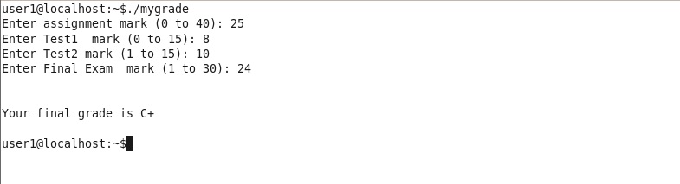

Upload your script to Brightspace.

**Assignment Grading Rubric (3%)**

|  |  |  |
| --- | --- | --- |
| **User Input** |  | /5 |
| **Calculate Grade** |  | /10 |
| **Evaluate Letter grade** |  | /15 |
| **Comments** |  |  |
| **Total Points** |  | /30 |